Remember progress on most recent goals and objectives!

What is the student’s current level of performance?

Summative and Formative Assessment Data

The purpose of the Present Level of Academic Achievement and Functional Performance (present level) section is to:

(Found in Participants and Profile section of IEP)

Based on existing data relevant to the area(s) of need, what prerequisite skills has the student mastered?

How will the strengths support the area(s) of need? What student strengths will assist in accommodating their need(s)?

What is the expected performance criterion?

Following analysis of student need(s), identify the level of that need:

1) Environmental changes 2) Intervention

3) Intensive Intervention 4) Supplemental Aides and Services

Do school behaviors/skills impact access to the general education curriculum and/or Post-Secondary vision/goals?

Reading, Writing, Math, Communication, Social/Emotional, Motor, Health/Medical/Physical, Cognitive/Developmental, Transition

How does the student perform throughout the school building in a variety of settings?

What is the student's current performance criteria with a specific skill/behavior?

Is the baseline data (numbers) included in the PLAAFP the starting point of specialized instruction, and will it help in the development of measurable annual goals?

Formative Assessment Data

Does the description of need give the "starting level," which will help in determining if the student has made progress and has benefited from specialized instruction based on reaching the "end level" (goal)?

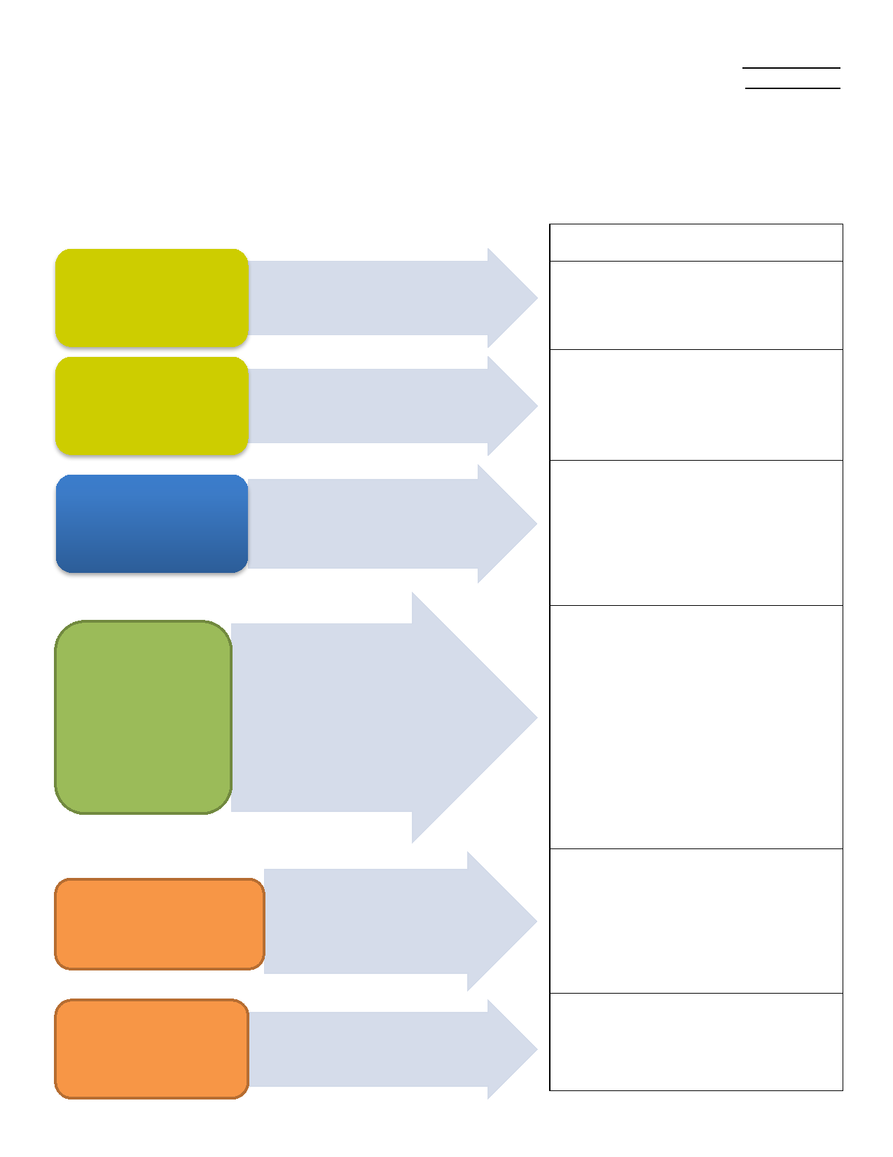

**STUDENT:**

**DATE:**

**PLAAFP/ADVERSE IMPACT DEVELOPMENT GUIDANCE**

* Describe the student’s current performance in areas affected by the disability
* Provide an overview of factors that impact the student’s performance
* Serve as the foundation/basis from which all other Individualized Education Program (IEP) components are developed

**Prioritized Area of Need that Requires**

**Specialized Instruction**

Current

Assessment Data

Expected Outcomes

Student Strengths

Description of Needs

Adverse Impact

Level of Need