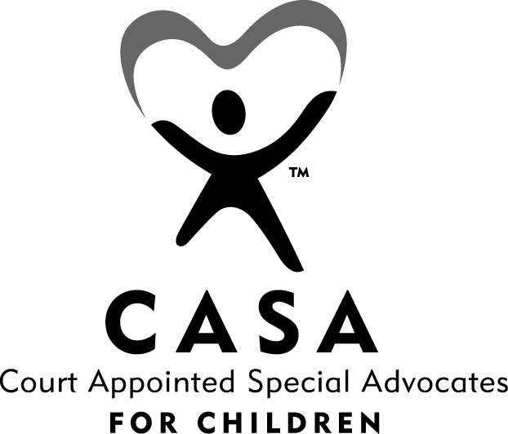

CASA of Monroe County Volunteer Application

Directions: 1) Please type or print legibly. 2) Complete application in its entirety.

Section I

Purpose and Use of Application Information

Thank you for your interest in working as a volunteer with the Monroe County CASA program. Our volunteers work closely with court employees and paid staff of the CASA program and are an integral part of the program. In every role, volunteers function under the same expectations as paid staff in terms of work attendance, dependability, adherence to established work procedures and compliance with professional standards of conduct. In turn, volunteers are assigned meaningful work. Acting as a CASA volunteer is a very rewarding experience.

The questions in this application are asked for the purpose of preliminary assessment of your qualifications as a CASA volunteer. This volunteer application contains much of the material included in paid staff applications, but with some differences. The information requested in Section II will provide a basis for evaluation of your qualifications as a volunteer. The information in Section III is essential to determine final approval of your application in regard to any previous law violations or treatment history.

While information requested in Section III is not an automatic barrier to final acceptance, it will be assessed and discussed with you regarding its relevance to your work as a CASA volunteer. The information is requested to expedite the application process. If you have any questions about completing Section II before learning if you will be accepted as a CASA volunteer, please contact the director or coordinator of the CASA program.

This application is the first step towards learning more about the CASA program. After the application is reviewed, we will schedule an interview (1 ½ hours) and answer any questions at that time. The screening process continues throughout the 30 hours of training, and concludes with a post-training interview. At that time either party, the volunteer or the CASA staff, may request to have the application withdrawn.

Thank you for your interest in CASA. We hope to hear from you soon.

Section II

Personal Information

Name:
 | (Last) |  |  |  | (First) |  |  |  |  |  |  |  | (Middle)
Address:
 | (Street) |  |  |  |  | (City) |  |  |  | (State) |  |  |  |  | (Zip)
Home Phone: |  | ( ) |  |  |  |  |  | Best Time to Call:
Cell Phone: |  | ( ) |  |  |  |  |  | Email Address:

Ethnicity: Hispanic or Latino Race: American Indian or Alaskan Native
Not Hispanic or Latino Asian
I choose not to answer Black or African American Native Hawaiian or Other Pacific Islander
White
I choose not to answer

Marital Status: Single Married Divorced Widowed I choose not to answer

Emergency Contact

In the event of an emergency during my volunteer work hours, notify:

 |  |  |  | ( )
(Name) |  | (Relationship) |  | (Phone)

Educational Background

Indicate your formal education (high school, college, postgraduate, business, technical, etc.)

School | Location | Major Courses | Degree | Date Received

Employment Experience

Begin with most recent employer. Use additional paper if necessary.

Employer | Phone | Position | Dates Employed
 | ( ) |  | –
 | ( ) |  | –
 | ( ) |  | –
 | ( ) |  | –
 | ( ) |  | –
 | ( ) |  | –
Have you worked in a state other than Michigan in the past 5 years? Yes No

Volunteer Experience

Begin with most recent agency. Use additional paper if necessary.

Agency or Employer | Position | Date(s) Volunteered
 |  | -
 |  | -
 |  | -
 |  | -

How did you learn about the CASA program?

Why do you want to volunteer?

Please list any strong interests, knowledge areas, hobbies, or special skills which you could offer as a volunteer:

Please list any languages you speak, other than English:

What experience or knowledge of children and families do you have to assist you in determining what may be in a child’s best interests (i.e. parenting experience, childcare experience, related education or work)?

Have you any experience with social service agencies as a staff person, foster parent, volunteer, or client? If yes, please explain.

Have you had any experience dealing with the juvenile or family courts systems? If yes, please explain.

Have you had any involvement with human services issues such as abuse, neglect, chemical dependency, developmental disabilities, mental health issues, traumatic physical illnesses? If yes, please explain.

In your opinion, what could the system do that it is not doing now to protect children?

Some volunteer duties may require the use of a car:

Do you have a car available to you for this work? Yes No

Do you have liability coverage for the use of this car? Yes No

Time Availability

How many total hours per week are you available?

Please indicate by checking morning, afternoon, and evening availability:

Monday | AM | PM | EVE |  | Friday | AM | PM | EVE
Tuesday | AM | PM | EVE |  | Saturday | AM | PM | EVE
Wednesday | AM | PM | EVE |  | Sunday | AM | PM | EVE
Thursday | AM | PM | EVE

Please list any additional information you feel would be helpful in assessing your application:

Acknowledgment and Permission to Conduct Record Check

I declare that all of the preceding information is true and correct to the best of my knowledge. I understand that any false or misleading information given by me can disqualify me from consideration or result in a separation at a later time. I understand that Court Appointed Special Advocate is an at-will position.

I hereby give my permission for the CASA of Monroe County Program to conduct a criminal record check and Department of Transportation check to obtain information for the purpose of assessing my qualifications for Court Appointed Special Advocate.

Signature |  | Date

Are you prepared to complete 30 hours of pre-service training and a minimum of 12 hours per year of in-service training? Yes No

Are you prepared to commit to at least one year of volunteer service? Yes No

I understand that the information requested in this application will be used only for the purpose of determining my suitability as a CASA volunteer. Further, I understand that completion of training does not guarantee that I will be assigned a case. I will be assigned to a case if I have successfully completed the training, have met all other requirements, and it has been determined that I am a suitable volunteer. I understand that I will be expected to serve as an advocate until the case I am assigned is closed. If unforeseen circumstances prevent me from fulfilling this obligation, I will submit my written resignation to the program director with as much advance notice as possible. I am aware of the sensitive and confidential nature of the official documents, reports, and other materials I will examine in my capacity as a CASA volunteer. I will discuss these matters only with those persons directly involved in the case or who will be consulted for their professional knowledge and expertise. I understand that if for any reason it becomes apparent that my activities are contrary to the policies, goals and/or philosophy of the CASA program and its mission, my services as a CASA volunteer will be terminated.

Signature |  | Date

Section III

Criminal Record History

The information requested in this section is essential to conduct the record check. You are not legally required to supply this information. However, if you choose to withhold this information, a final decision on your application cannot be made.

Driver’s License Number: |  |  |  |  |  |  |  | Date of Birth: | / /
Gender: | Female Male |  | Race: |  |  | Social Security #: |  |  |  | - -

List any other name by which you ever have been known or are now known as:

Have you been convicted of a law violation other than a minor traffic offense? Yes No

If yes, what was the offense(s)?

Date convicted:

End of probation, parole, or court jurisdiction:

Do you have any friends or relatives confined at the:

- Monroe County Jail Yes No
- Monroe County Juvenile Detention Center Yes No
- Michigan State Prison Yes No

If yes, please list name(s) and relationship:
Name |  | Relationship

Treatment History

Volunteer applicants who have received treatment services (residential or outpatient treatment, correctional programs) cannot be immediately accepted as a CASA volunteer. In these instances, it is necessary for the applicant to have made a satisfactory community adjustment for at least one year before acceptance as a CASA volunteer.

Have you ever experienced / received treatment for drug, alcohol, or mental health problems?
Yes No (You may discuss details in a confidential interview.)

References

Please list three (3) personal references, other than relatives, that can attest to your character skills and dependability. One reference should be a co-worker, if employed. (Other examples: minister, teacher, therapist, etc.) References will be contacted.

Name: |  |  |  |  | Relationship:
Address:
City: |  |  |  |  | State: |  |  |  | Zip:
Email:
Phone: | Work | ( ) | Home | ( ) |  |  |  | Cell |  | ( )

Name: |  |  |  |  | Relationship:
Address:
City: |  |  |  |  | State: |  |  |  | Zip:
Email:
Phone: | Work | ( ) | Home | ( ) |  |  |  | Cell |  | ( )

Name: |  |  |  |  | Relationship:
Address:
City: |  |  |  |  | State: |  |  |  | Zip:
Email:
Phone: | Work | ( ) | Home | ( ) |  |  |  | Cell |  | ( )

Applicant Signature |  | Date

NOTE: Please attach any additional information you want to submit and return it along with this application (within 15 days) to:

Jerica Sharp, Director
CASA of Monroe County Email: jerica.sharp@monroeisd.us
9 Washington St., Suite C
Monroe, MI 48161

