Monroe County ISD Guidance: Procedures for Timely IEPs

The Monroe County Intermediate School District does not discriminate on the basis of religion, race, color, national origin, sex, disability, age, height, weight, marital status or familial status in its programs, activities or in employment. The following person has been designated to handle inquiries regarding the non-discrimination policies: Elizabeth J. Taylor, Assistant Superintendent for Human Resources and Legal Counsel, 1101 S. Raisinville Road, Monroe Michigan 48161; Telephone: 734.322.2640.

GUIDELINES AND PROCEDURES FOR TIMELY IEPS:

A PREVENTATIVE APPROACH

Purpose

The primary purpose of this document is to provide guidance to ensure that students’ Individualized Education Programs (IEPs) are completed in compliance with timeline requirements, as established by the Individuals with Disabilities Education Act (IDEA) 34 CFR Regulations.

- The implementing regulations for the IDEA clearly state at § 300.323(a) that each public agency must have in effect an IEP for each child with a disability within its jurisdiction. The requirement to have a current, or active, IEP is a federal requirement. The provision of a free appropriate public education (FAPE), at § 300.17(d), is predicated on a student having a current IEP. The overdue IEP issue must, therefore, be corrected immediately.

- Additionally, IDEA§300.324(6)(b)(i) requires that public agencies, at minimum, review the child’s IEP periodically, but not less than annually, to determine whether the annual goals for the child are being achieved.

- The Michigan Department of Education (MDE) is required by the IDEA to make annual determinations for every local district in the state. The U.S. Department of Education (USED), Office of Special Education Programs (OSEP) instructions require that states must consider, as part of determinations, whether data submitted by local districts are timely, valid and reliable.

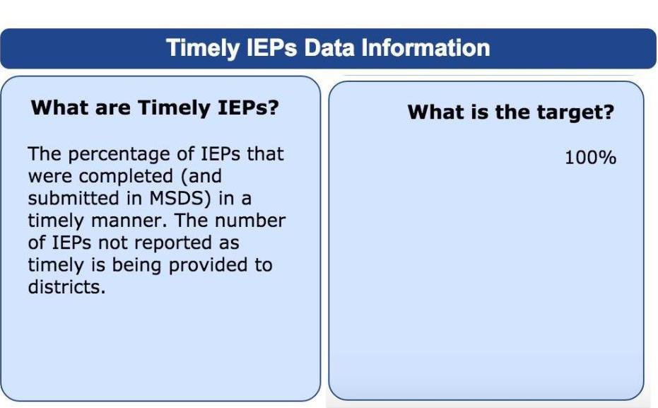

What is an Untimely IEP?

An IEP is considered untimely if it is held 365 days or more after the prior IEP’s offer of a FAPE. The annual IEP time frame begins on the date Notice was signed by the district, not the date of the IEP meeting (unless Notice was signed at the meeting).

What reasons are “allowable” when reported in the Michigan Student Data System (MSDS) for a late initial Individualized Education Program (IEP)?

- IEP Not Timely: Parent did not make the child available (Code 13).
- IEP Not Timely: Timeline began in previous district (Code 14).
- IEP Not Completed: Student died (Code 18).
- IEP Not Completed: Parent withdrew consent (Code 19).
- IEP Not Completed: Parent did not make child available (Code 20).
- IEP Not Completed: Student moved (Code 21).
- Child moved into Michigan from another state with a current IEP (Code 22).

What reasons for late initial IEPs will result in a finding of noncompliance?

- IEP Not Timely: Personnel not available for evaluation (Code 15).
- IEP Not Timely: Personnel not available for IEP meeting (Code 16).
- IEP Not Timely: External reports not available (Code 17).

How do I avoid an untimely IEP?
The practices that follow will help all staff avoid having an untimely IEP.

Keep Caseloads in PowerSchool Special Education (PSSE) Up to Date
It is the responsibility of all service providers (e.g., those carrying a caseload) to keep caseloads current and accurate in PSSE. This practice allows for PSSE reports to support the work of the service provider. Any changes to caseload need to go through Jacqui Venier at MCISD (734) 342-8625, or jacqueline.venier@monroeisd.us.

Monitor Due Dates
It is the responsibility of the case manager to monitor due dates for annual review IEPs. It is the responsibility of the IEP team (special education teacher, school psychologist, and any other involved service providers) to monitor due dates for reevaluation IEPs.

PSSE provides easy to use reports to track both annual review IEPs and reevaluation IEPs. In PSSE, click on your homepage report (listed below). Please note that if the user’s caseload is inaccurate, this report will also be inaccurate.

Imported Reports
- MCISD IEPs&Reevals by Building due in next 45 days
- MCISD IEPs&Reevals by Caseload due in next 45 days

Avoid Block Scheduling
IEPs should be scheduled one year from the last annual review IEP and three years from the last reevaluation IEP. Avoid scheduling groups of IEPs during the same day or week.

Schedule IEP Team Meeting 2 Weeks Prior to the Due Date
All IEPs should be scheduled in collaboration with parents and service providers two weeks prior to the IEP due date to provide time for rescheduling in case of inclement weather or other school cancellations.

Note: IEPs must be held at least one school day earlier than the date it was held the previous year. Best practice: give yourself time (allow for unplanned closures).

Example: If an IEP is held on October 4, 2018 the next IEP must be held on, or prior to October 3, 2019. An IEP held on October 4, 2019 would be considered untimely

Provide Timely Notice
According Michigan Special Education One-Pager: Notice (2012), “notice is written information given to the parent by a district to explain an action the district wants to take or is refusing to take with a student who has a disability or suspected of having a disability. Notice provides the reasons that the district is proposing or refusing an activity.” Notice is required at various times throughout the Special Education process, but always when an offer of FAPE is made as part of an Individualized Education Program.

Notice of FAPE is embedded in a PSSE IEP as the last section of the IEP. Date of Notice is submitted to Michigan Department of Education along with the date of the IEP meeting. The Initial IEP Timeliness code in Office Use Only section is also reported to MDE.

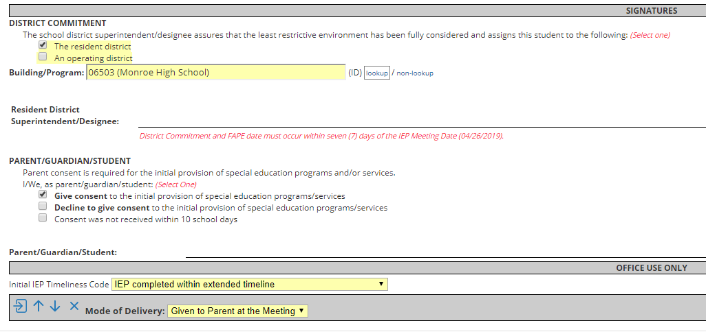
- Best practice indicates that provision of Notice should occur at the conclusion of the IEP meeting by giving the parent a copy of the completed IEP at the end of the meeting.

- Notice may also be provided within 7 school days of the IEP by sending the document home. Mode & Date of Delivery of Notice must be indicated in the Office Use Only section at the bottom of the document.

Initial IEP Extension to Evaluation Timeline

If you have received parental consent to extend the evaluation timeline, ensure that you hold the meeting on or before the agreed upon date.
- In the Notice section, below the Parent/Guardian consent to the initial provision of FAPE, you MUST enter the Initial IEP TImeliness Code correctly. If you do not accurately reflect that the IEP was held within the agreed upon extension timeline, the IEP will be inaccurately reported as untimely.

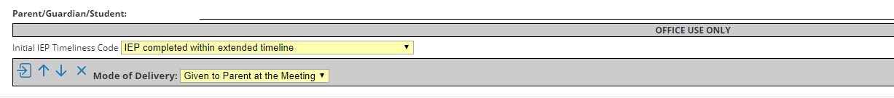

Where does the signed, original copy of the IEP go?

- Ensure the electronic copy in PSSE is up to date before finalizing.
- The electronic copy and the original in the CA60 should be the same, except the CA60 will house the original signatures.
- Ensure the signed, original IEP is in the correct cumulative file (CA60).

Who do I submit copies of signed, finalized documents to?

- Building ISD staff will scan signed original documents and email to the regional secretary to file into CEO. Attach RMS to email. CC Jacqui Venier.
- Resource program staff and support staff will scan signed original documents and send them to Jacqui Venier to file into CEO. Attach RMS to email.
- Send a copy home.
- Send a copy to designated building staff, if applicable.

Please note: IEPs must be implemented as written. Document delivery of programs, services, and accommodations/modifications.

