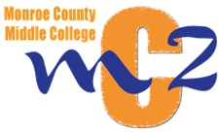

Students of the Monroe County Middle College are required to perform 50 hours of community service prior to graduation. The service is volunteer work and the student should be of assistance to another group or individual. The purpose of this activity is for young people to understand the benefits of helping others and what a difference this can make in their lives. If a student has volunteered their time and effort to you or your group, please fill out the form below so the hours are documented appropriately.
Thank you,
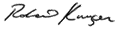
Robert Krueger
MCMC Principal

This certifies that ___________________________________________ has completed _____________
(student name)
hours of community service.

Name of Organization: ________________________________________________________________

Date(s) student has volunteered: ________________________________________________________

Coordinator signature and telephone number:

________________________________________________ _______________________________
Coordinator Signature Telephone Number

Student signature and graduation year:

________________________________________________ _______________________________
Student Signature Graduation Year

