MONROE COUNTY INTERMEDIATE SCHOOL DISTRICT
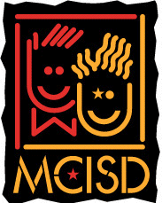
Human Resources Department and Legal Counsel
1101 S. Raisinville Road
Monroe, Michigan 48161
734-242-5799 x 1200/1210 FAX 734-322-2660
www.misd.k12.mi.us

HAZARDOUS MATERIAL TRAINING

The Michigan Occupational Safety and Health Administration has adopted revised Hazard Communication Standards called the “Globally Harmonized System” or “GHS” to align with federal and global standards for labeling and handling chemicals.

I ACKNOWLEDGE THAT I HAVE VIEWED THE WEBINAR ON HAZARDOUS MATERIAL TRAINING.

Name: __________________________________

Position: ________________________________

Signature: _______________________________

Date: ___________________

Please return this form to Human Resources.

